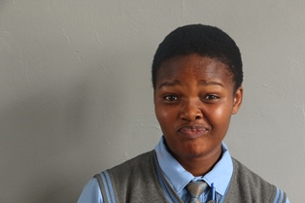
learner low_Nolwazi Mkhonto Grade 11
“Testing should happen in schools, after proper education.”

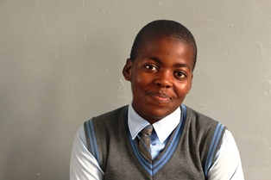
learner low_sibusiso mkhonto grade 10
“Condoms should be available in schools, from someone learners trust.”
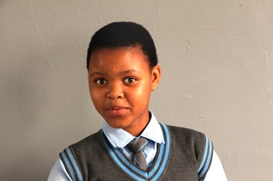
learner low_Nene Zanele Grade 10
“We need condoms to protect us from pregnancy and HIV.”
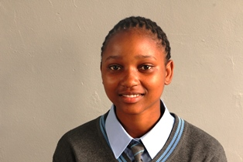
learner low_zulu nokuphila grade 10
“Learners rush home after school, so testing should be done in school hours.”
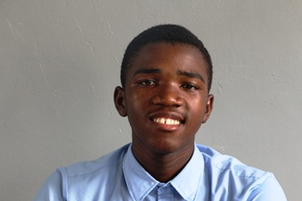
learner low_zungu andiswa grade 10
“We come to school to learn, not for sex!”
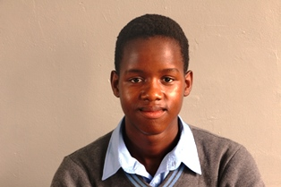
learner low_Bhengu Sanele Eunice Grade 9
“It is important to know your status at any age.”
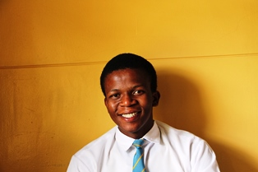
learner low_Mchunu wandile grade 11
“I don’t see why girls as young as 12 shouldn’t have condoms for protection.”
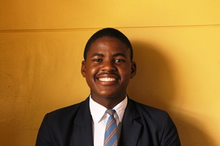
learner low_Dlamini Melokuhle grade 11
“Take advice on sexual and reproductive health from adults, not peers!”
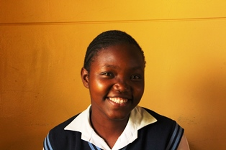
learner low_Nonqubeko Mnguni Grade 10
“Peer pressure makes us vulnerable to underage pregnancy.”
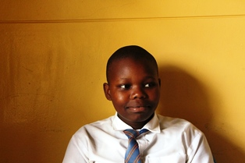
learner low_cebo zungu grade 11
“Condoms should be available everywhere.”
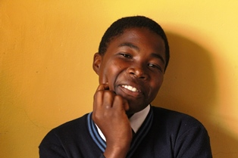
learner low_Thabiso Dlamini Grade 11
“Children should not be given condoms in schools. Sex isn’t a school sport!”
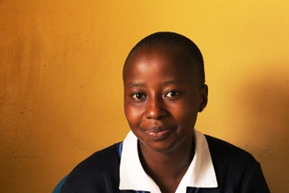
learner low_Lwethu Khumalo Grade 11
“Safe behaviour is best learned at home.”
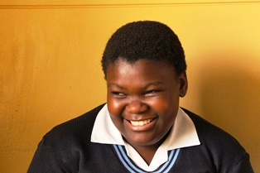
learner low_shandu fezeka grade 10
“The best sexual and reproductive health advice is ‘avoid boys’!”
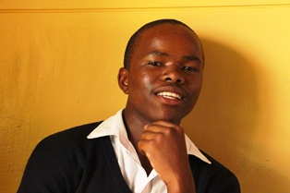
learner low_Lucky Zikhali grade 11
“Learners will never ask a teacher for a condom. They should be accessible in toilets.”

